Contents

User Manual 1

Application Purpose 1

Installation guidelines 1

Pre installation 1

Data files 1

Configuration file 1

Jars 1

Application screens 2

Login Window 2

All Tabs Window 2

Tab 1: Overview tab 2

Tab 2: Search Movie Tab 3

Tab 3: Social Tab 3

Tab 4: Recommendation Tab 4

Tab5: Settings Tab 4

Movie Details Window 5

Preferences Window 5

Import Window 6

Running the YAGO import 6

# 

# User Manual

## Application Purpose

Dione is a recommendation engine for movies, based on collaborative filtering. Dione allows users to describe a movie via tags, and rate tag relevance to movies. We also allow users to rate movies, and thus, establish the user's taste – which tags he prefers. We can therefore, recommend other movies, based on the crowd-sourced task of tagging movies. We encourage contribution, by means of social interaction – friendships, and notifications about friend activities that include comments on movies, movie ratings and tagging.

## Installation guidelines

### Pre installation

You must copy the IMDB and YAGO files to perform data update. Also, run the schema creation and the default user and person creation Script, provided/

### Data files

The DataFiles Directory of the project, Should include YAGO and IMDB files, specified in the Running the import section.

### Configuration file

The configuration file, can be found in "/dione/src/config.properties ". This file is written in a key=value fashion, and is parsed with the java.util.properties class. A configuration class, defines a set of getters, each hardcoded to retrieve a different property. Properties include file paths, UI style definitions, some YAGO/IMDB parsing definitions, DB connection attributes and pooling properties.

### Jars

* swt
* mysql-connector-java-5.1.25-bin

## Application screens

Login Window

This window allows logging in as an existing user, or signing up as a new user. Only usernames and passwords with 4-10 characters are allowed. Note: after the first login by any user, a rate movie window will be opened and will let the user rate movies.

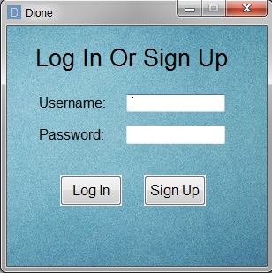

### All Tabs Window

The main window of Dione. This is a tab's oriented window, consists of five tabs. Note that in order to see updates of new data, like recommendation or recent activities the user should log out and log in again.

Tab 1: Overview tab

The default tab, first shown after logging in. This tab consists of general information for the logged in user.

A short list of most recommended movies for the user is shown. A click on each of the movies will open it's Movie Details Window.

A short list of tags that describe movies that seems to be favorable by the user is also shown.

Note that the recommended movies and favorable tags will be shown after Dione will get the chance to learn the user's taste. A short list of the user recent activity in Dione is also shown.

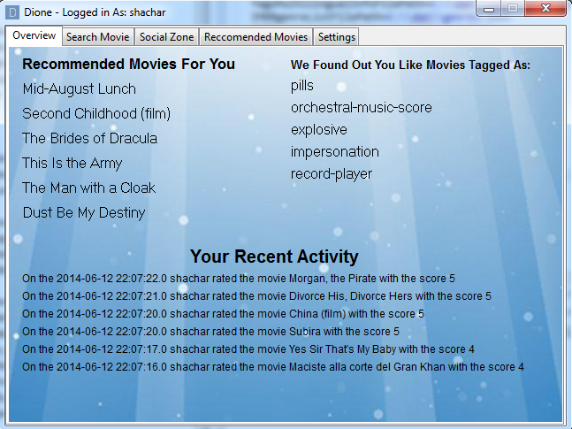

Tab 2: Search Movie Tab

This tab allows the user to search for movies by various criterions: title, director, language, actors (up to three), years range, associated movie tags and movie genres.

The search results are shown in a scrollable list. A click on a movie will open it's Movie Details Window.

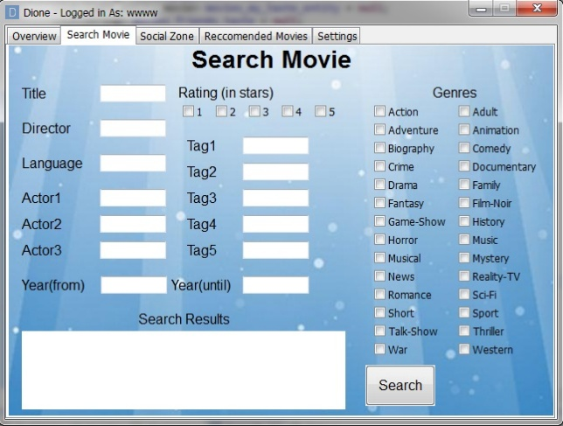

### Tab 3: Social Tab

his tab allows the user to manage his friendships with other users in Dione. The user can add a new friend or remove an existing friend (his friends are shown in a drop-down list). This tab also consists of the user recent social activity, and his friends recent (general) activity.

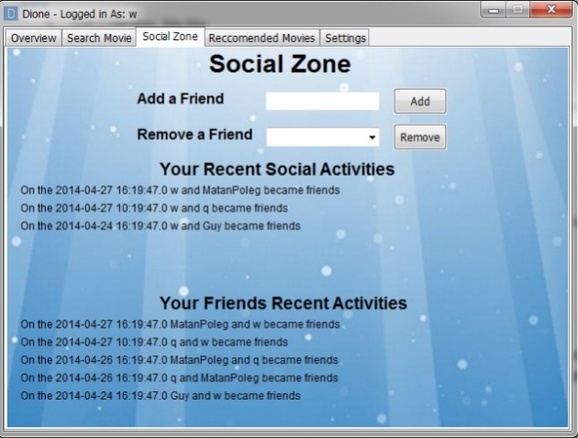

### Tab 4: Recommendation Tab

This tab allows the user to enjoy the smart engine of Dione.

Dione recommends the user movies based on what it learned about him, and based on his friends taste. These are shown to the user in this tab, as well as the generally top rated movies in Dione. A click on a movie will open it's Movie Details Window.

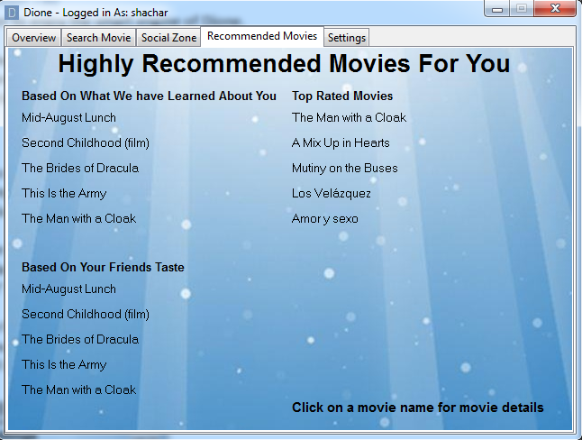

### Tab5: Settings Tab

This tab consists of account modification options, and some other options. In the settings tab the user can change his username and password (each of them requires the current password for verification).

This tab also allows the user to make a massive data update, a process which may take a lot of time. During the data update, there will shown a progress bar to indicate the update, which include an 'Abort' button to stop the update.

A button named 'Rate Random Movies' will open the Preference Window, which allows the user to rate random movies (which will help dione learn more about the user).

A log out button – will log the user out of Dione, and open the log in window.

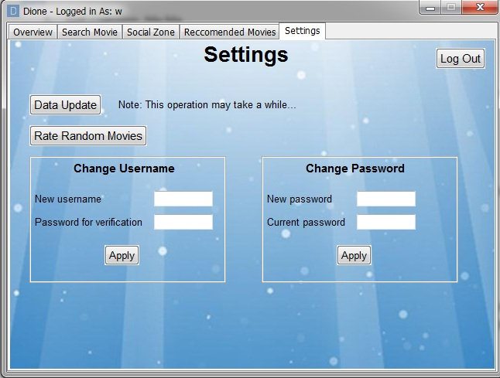

### Movie Details Window

This window consist of all the available data of the selected movie.On the top of the window will be shown the movie title. The data that will be shown consists of genres, director, year, rating(1-5), star players, a clickable Wikipedia link, movie plot and tags associated with the movie.

The user can rate the movie, and can rate the relation of any shown tag to the movie (i.e how much he believes this tag is associated with the movie). The user can also add a new tag (that is already existed in the system) to be linked with this movie.

The user can make a short comment about the movie (by clicking 'Make a Comment'), and can watch the recent comments about this movie (by clicking 'Recent Comments').

The last two windows will be closed if the main movie details window will be closed.

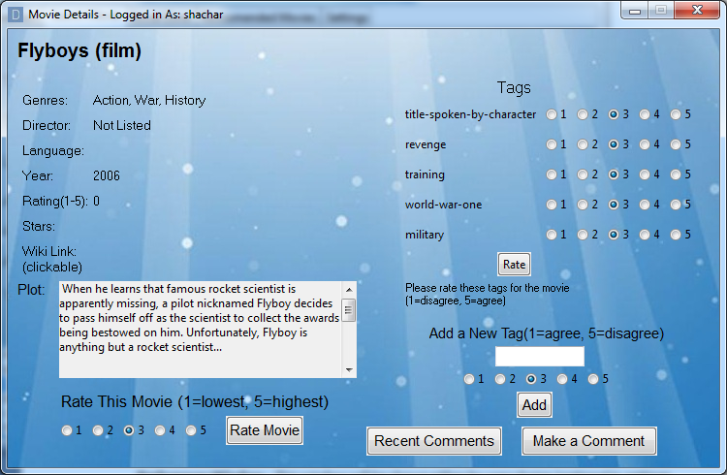

Preferences Window

This window will be shown either by user choice (optional in settings tab), or for any first log in of a new user. The user will be shown a random picked movie to be rated in a scale of 1-5 ('don’t know' option is also available). Every rate will get another random movie to be rated. This process will continue until the user will click the 'Stop Rating' button, which will close the window.

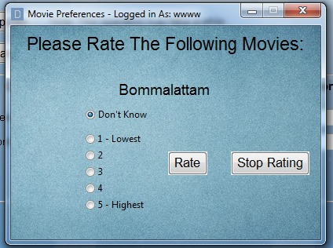

Import Window

This window will be shown to the user only if a first data import hasn't yet been made, and finished successfully. It consists of a single button which will run the data import.

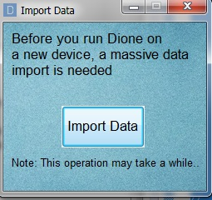

## Running the YAGO import

The import must take place before Dione can run. If an import hasn't yet been made (or there were only unsuccessful imports), the user will be enforced to run data import. At any point, the user can run a data update via the settings tab. Import beginnings and successful terminations are recorded, for this purpose.

YAGO files can be downloaded from:

<http://www.mpi-inf.mpg.de/departments/databases-and-information-systems/research/yago-naga/yago/downloads/>, and the files are:

* yagoFacts.tsv
* yagoLiteralFacts.tsv
* yagoMultilingualInstanceLabels.tsv
* yagoSimpleTypes.tsv
* yagoWikipediaInfo.tsv

IMDB files can be downloaded from:

<ftp://ftp.fu-berlin.de/pub/misc/movies/database/>, and the files are:

* directors.list
* genres.list
* keywords.list
* language.list
* plot.list
* taglines.list
* aka-titles.list

Updating file paths, to be used by the importer, can be done via the configurations file, as specified in the configurations file section.